**SOP for Nickel Analysis**

* turn on the ventilation using the wall switch

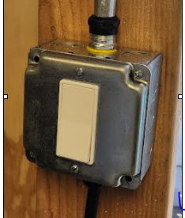

* turn on the AA using the following switch

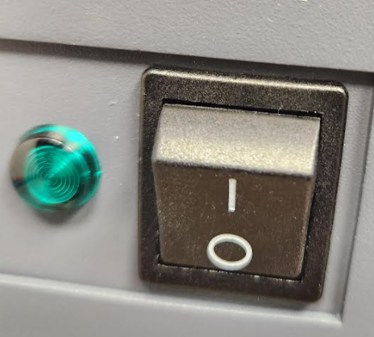

* Remove the burner door (it has an interlock and the burner will not turn on without putting the door back in its place.)

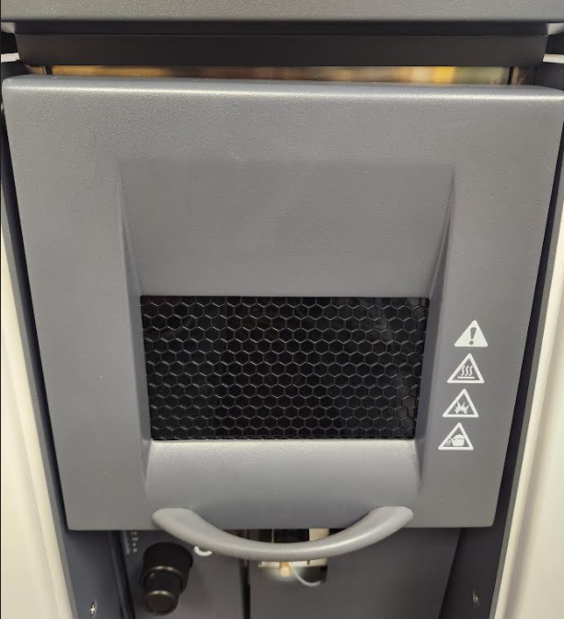

* Make sure that you have the right burner installed: Air/Acetylene burner for Nickel.

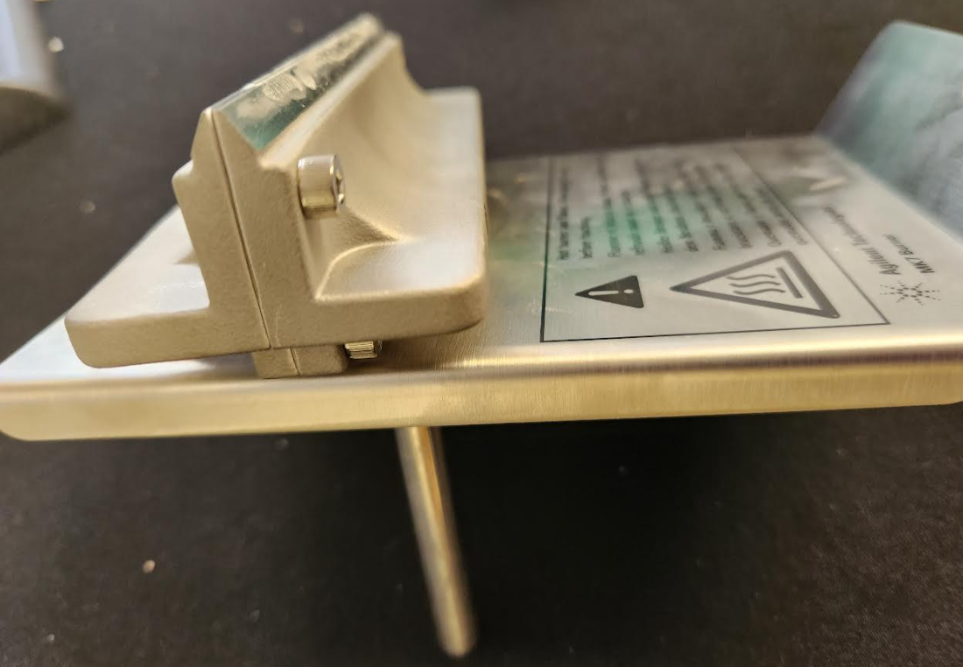

Air/Acetylene Burner

Also make sure that the burner is clean (cleaning of the burner should be done daily).

1) remove the burner by pulling it out of its place.

2) Use a business card to clean the gap. If burner is very nasty, you can use 5% HNO3 solution for cleaning the burner.

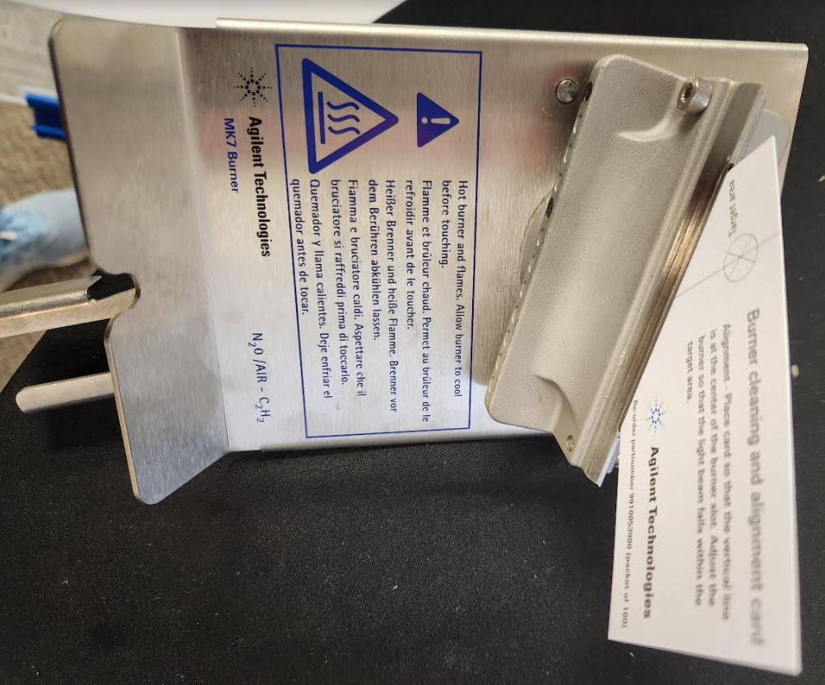

3) Make sure that the O-ring is not damages. If it is damaged, change that.

Apiezon grease can be used for the O-rings.

Once a year we need to schedule for the cleaning of the nebulizer and calibration of the instrument.

5) remove the waste cover. It is only cosmetic and you do not need that for the work of the equipment.

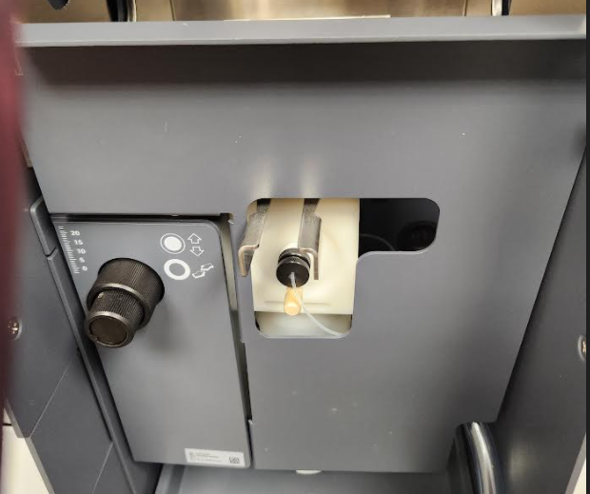

* Make sure that the vessel is filled with DI water + 2.5% nitric acid. The burner will not start if it is not completely full. Also make sure that the waste tube is in the waste container. You can unscrew the vessel and remove it for cleaning and adding water to it.

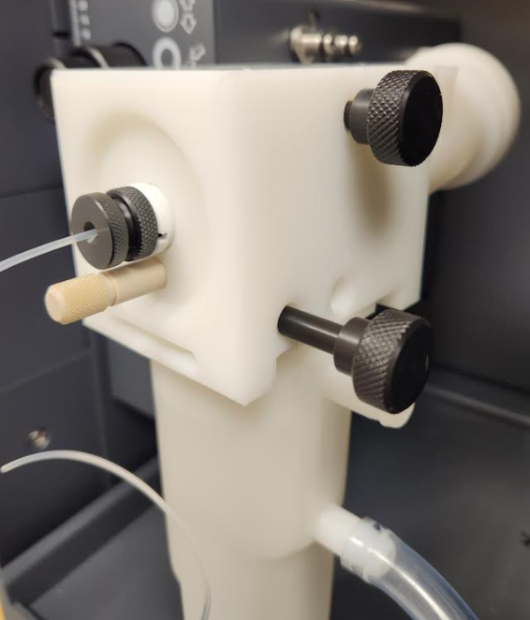

If the following part of the vessel blows off during the AA work, stop the work and contact Agilent to investigate.

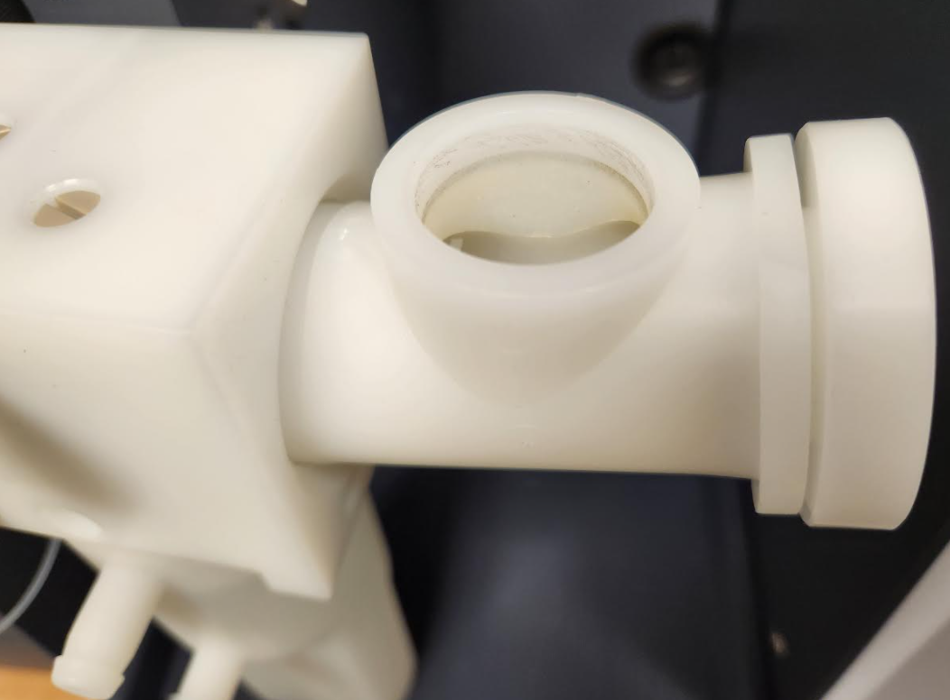

* Put the vessel and the burner back in their places. Screw the vessel in its place.
* Open the valve of acetylene and air gasses (do not play with the regulator valve. Only turn on the main valve)

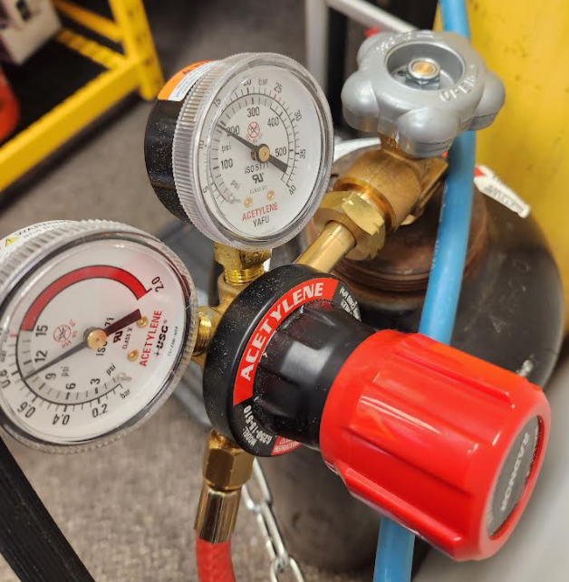

Acetylene: 11 Psi, Never exceed 15 Psi (total pressure of the tank should never goes bellow 100 psi otherwise we lose the warranty.

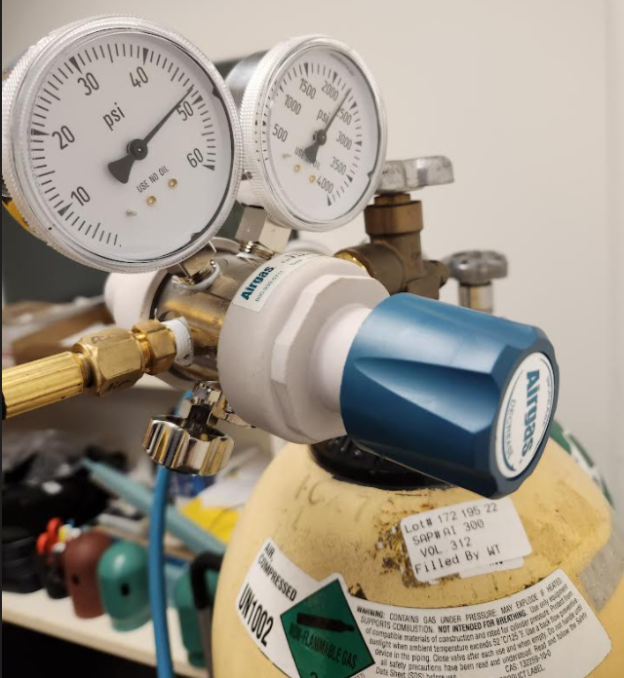

Air: 50 psi

* Check the alignment with the business card.
* Open the software

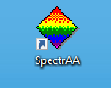

* Click on Worksheet, New from “Cr, Cu, Fe, Ni” method

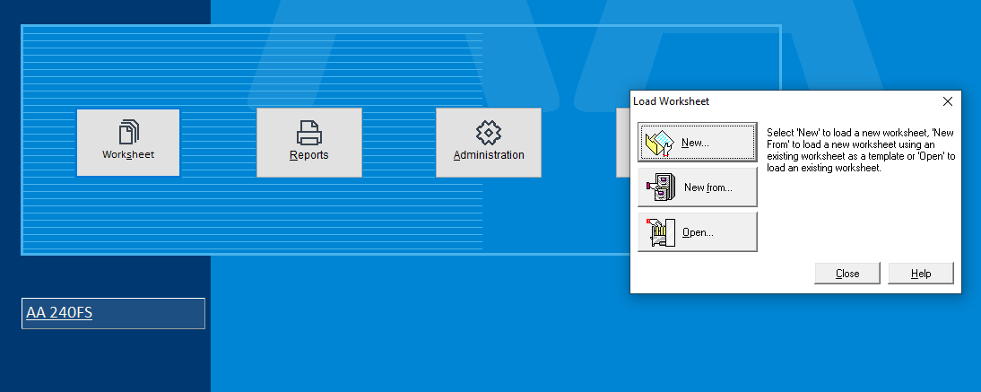

Click on Catalog on the analysis page:

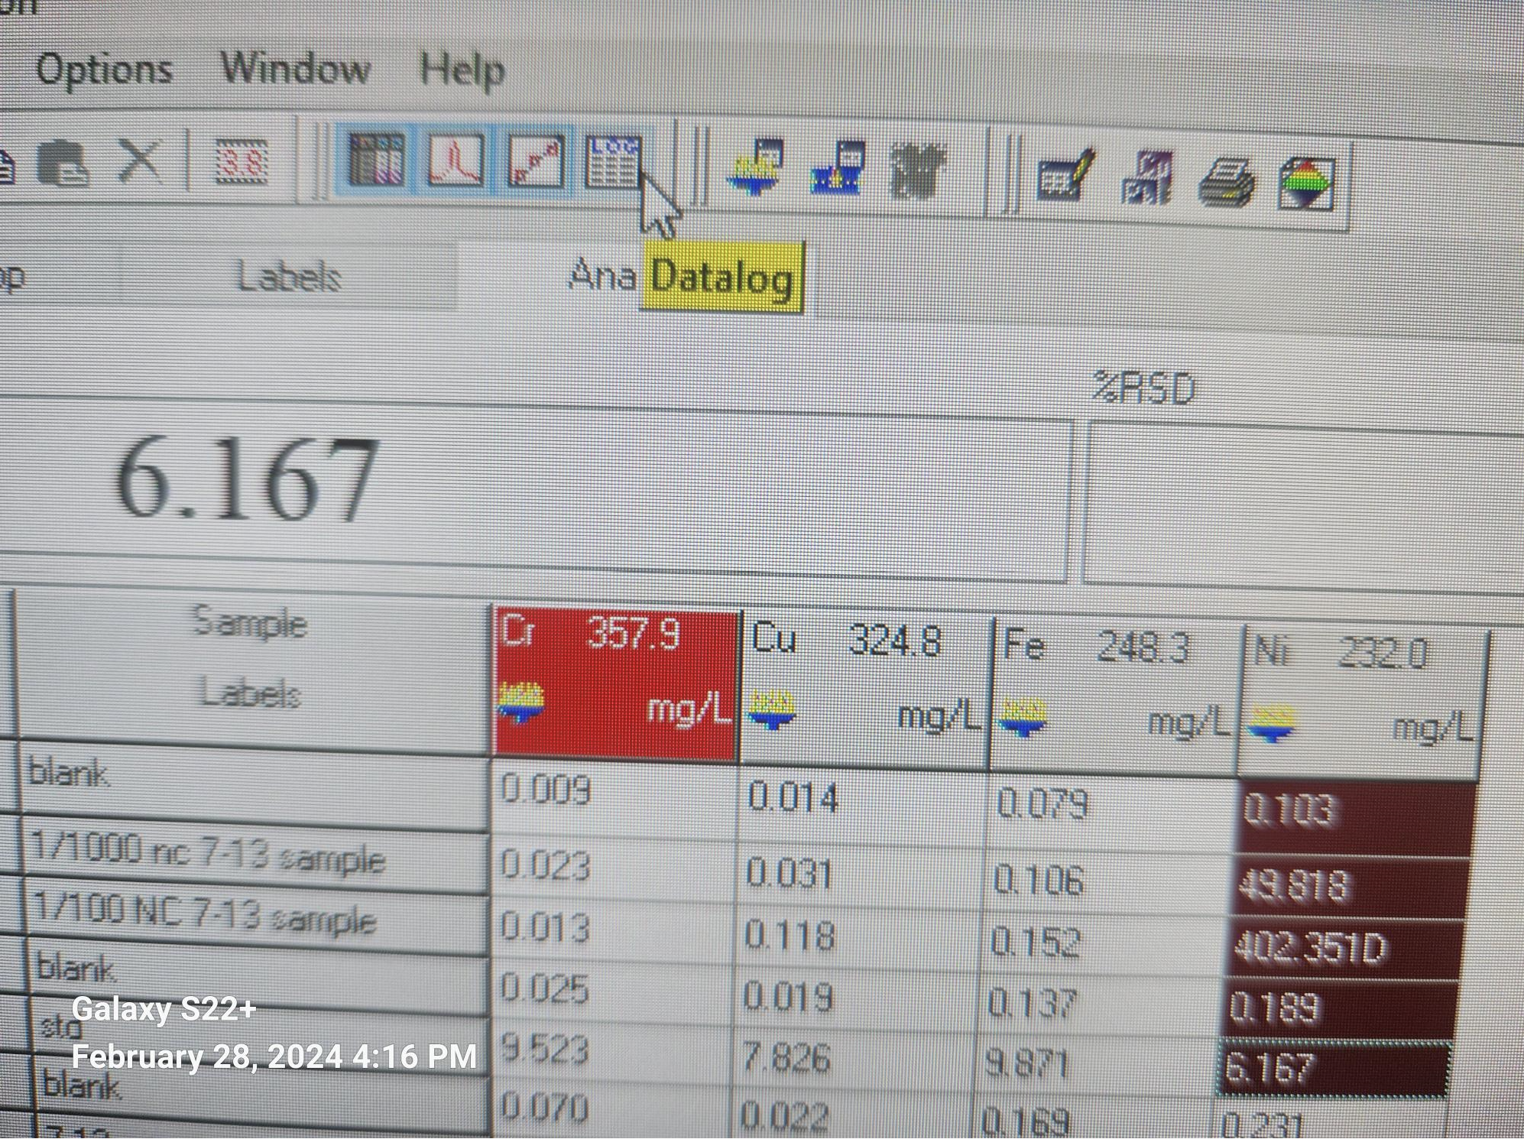

You can check your method in Develop/Edit Method

Name it Date-customer-initia of the person

Only the red selected lines will be run.